CS 677 (72828) – Machine Learning Project Conclusion Summary Report
Hourly Bike-Sharing Demand Prediction
Introduction:
Bike sharing is a system where people rent bikes for short durations instead of owning the bike. They are essentially getting the bike using an app or card and riding it where they need to be. They do have to return the bike to a station or leave it in a specific location. Users are paying only for the time that they use it. An example of this would be the Citi Bikes that we see around New York City.
Our objective is to develop a machine learning regression model capable of accurately predicting hourly bike-sharing demand. Our prediction task relies on explanatory variables such as weather conditions, seasonality, time of day, and calendar-related factors like holidays and working days. For bike-sharing systems, accurate hourly demand prediction is essential for operational planning, bike redistribution, and resource allocation.
Models Evaluated:
To address the problem statement, we used the four regression algorithms listed below and evaluated them:
- Decision Tree Regressor
- Random Forest Regressor
- Support Vector Regression (SVR) with RBF Kernel
- Stochastic Gradient Descent (SGD) Regressor
We trained each model on preprocessed data and evaluated using validation and test sets to ensure fair comparison and generalization assessment.
Evaluation Metrics:
We assessed our model performance using the following metrics:
- Mean Squared Error (MSE): Measures the average squared difference between predicted and actual values. This metric penalizes large errors.
- Mean Absolute Error (MAE): Measures the average absolute prediction error. This provides intuitive interpretation.
- R² Score: Indicates the proportion of variance in bike demand explained by the model.

Performance Results - Validation and Test Performance:
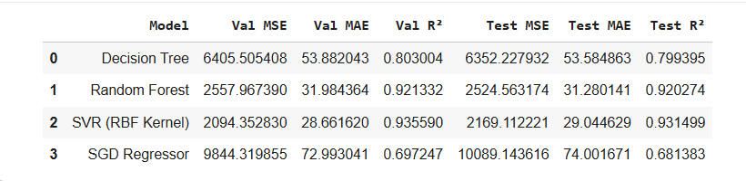
Best-Performing Model Selection:
Based on the test-set performance above, we selected Support Vector Regression (SVR) with an RBF kernel as the best-performing model.
- The SVR achieved the lowest Test MSE (2169.11) indicating the smallest overall prediction error.
- The SVR also produced the lowest Test MAE (29.04), meaning its average hourly prediction error was approximately 29 bike rentals, which is acceptable for real-world demand forecasting.
- SVR obtained the highest Test R² (0.9315), explaining more than 93% of the variability in hourly bike demand.
- The SVR model demonstrated strong generalization capability, as indicated by the small difference between validation and test metrics:
- Validation MSE: 2094.35 vs Test MSE: 2169.11
- Validation R²: 0.9356 vs Test R²: 0.9315
This consistency indicates that the model is not overfitting and performs reliably on unseen data.
Explanation of Superior Performance:
Hourly bike-sharing demand is influenced by nonlinear relationships, such as the interaction between weather conditions, time of day, and type of day. The RBF kernel used in SVR is suited for modeling nonlinear patterns by projecting input data into a higher-dimensional space.
In comparison, the Decision Tree showed weaker generalization due to its sensitivity to data splits and limited ability to model smooth relationships. The SGD Regressor, being a linear model, failed to capture complex nonlinear patterns in demand. The Random Forest performed strongly by reducing variance through ensemble learning. However, the Test MSE and R² were still inferior to those of SVR.
Regarding Computational Efficiency and Model Complexity, SVR with an RBF kernel is computationally more expensive than simpler models such as Decision Trees or SGD. Despite this, the performance gains justify its selection.
Conclusion:
In conclusion, we selected Support Vector Regression with an RBF kernel as the most suitable machine learning algorithm for predicting hourly bike-sharing demand. It achieved the lowest prediction errors and highest explanatory power among all evaluated models while maintaining good generalization performance. These results align closely with our problem objective of accurately modeling complex, nonlinear demand patterns in an urban bike-sharing system.

